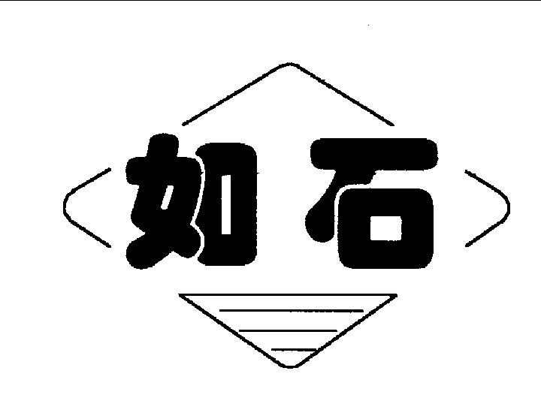

TQ340/35Y₂

POWER CASING TONG

OPERATION MANUAL

TQ340-35Y-SM

STANDARD: SY/T 5074-2012
API Spec 7K 5th

PRODUCTION PERMIT:

XK14-002-00020

JIANGSU RUSHI MACHINERY CO.,LTD
Add：No.60 Weihai North-Road, Bencha, Rudong, Jiangsu, China
P.C.：226406 Tel：0513-84890912 84890937 Fax：0513-84821168
http://www.jsrushi.com E-mail:rslzg@jsrushi.com
（Pre-Rudong Petroleum Machinery Factory）

CONTENTS

SECTION Ⅰ INTRODUCTION
SECTION Ⅱ PERFORMANCE PARAMETERS
SECTION Ⅲ INSTALLATION

SECTION Ⅳ OPERATION INSTRUCTIONS
SECTION Ⅴ MAINTENANCE

SECTION Ⅵ TROUBLE SHOOTING
SECTION Ⅶ ATTACHED FIGURES
SECTION Ⅷ LUBRICATION
SECTION Ⅸ PRESSURE TORQUE GAUGE AND OIL FILLER
SECTION Ⅹ RECOMMENDED SPARE PARTS
SECTION Ⅺ HYDRAULIC LIFT CYLINDER
SECTION Ⅻ API RECOMMENDED TORQUE FOR 4¹/₂″-13³/₈″CASING

SECTION Ⅰ INTRODUCTION

TQ340/35Y₂ Power Casing Tong is used to make up and break out for casing operation in oil fields. It greatly reduces the labor of worker, enhances connection quality of thread and diminished accidents in inappropriate casing operation.
Features:
l. Opening type, convenient and prompt to enter and slide off the working position, with an integral tong head of great strength and rigidity.
2. Double swing head jaws, very convenient to assemble and disassemble, with the best design for tangent-diameter ratio, ensuring the reliability of gripping and easy cam- backslide.
3. Band brake of great moment, easy to operate and convenient to maintain and replace.
4. Notched gear new type sporting structure, greatly improving the strength and rigidity.
5. Wholly hydraulic mode. High torque motor of swing cylinder type will supply effective power. The power tong takes mechanical gear changing and its structure is simple and reliable.
6. The shell is thickened with Mn. The jaws are cast with precise technology, artistic and strong.
7. The hydraulic torque gauge as well as the joint for a round-torque gauge makes it possible for computers to manage the process.

SECTION Ⅱ PERFORMANCE PARAMETERS

Ⅰ. Technical parameters
1. Suitable pipe 4"- 13³/₈" (101.6-340mm)
2. Opening size 13.78" (350 mm)
3. Head spinning speed high 50-86 rpm
low 8-14 rpm
4. Max. torque high 2580-4425 ft.lbf (3.5-6 kN. m)
low 16225-27285 ft.lbf (22-37 kN. m)
5. Maximum working pressure 2900 psi (20 MPa)
6. Working flow 29-45 gpm (110-170 L/min)
Max. working flow 52.5 gpm (200 L/min)
7. Overall dimensions 62.2"×35.4"×33.9" (1580×900×860 mm)
8. Weight 1670 lb (760 kg)
Ⅱ. Speed and Torque Comparison (see Table 1, 2)

Table 1 Speed under different flow
Flow  GPM (L/min) | Speed (rpm)
Flow  GPM (L/min) | High gear | Low gear
29(110) | 48 | 7.6
32 (120) | 52 | 8.3
37 (140) | 61 | 9.7
42 (160) | 70 | 11
47.5 (180) | 78 | 12.5
53 (200) | 86 | 14

Table 2 Max theoretical torque under different pressure
Pressure  PSI (MPa) | Torque ft.lbf (kN.m)
Pressure  PSI (MPa) | High gear | Low gear
1450(10) | 2212 (3) | 13275 (18)
1740 (12) | 2580 (3.5) | 16226 (22)
2030 (14) | 2950 (4) | 19176 (26)
2320 (16) | 3540 (4.8) | 22126 (30)
2610 (18) | 3982 (5.4) | 24340 (33)
2900 (20) | 4425 (6) | 27290 (37)

SECTION Ⅲ INSTALLATION

Ⅰ Hang the tong (see Fig.4)
l . Fix the single pulley (3.3 US ton) under beam of the crown block.
2. Get a wire rope (at least 1/2") through the pulley, with one end fixed on the base beam. The height of the tong should be at the same level as the average height of joint during making up and breaking out casing.
Ⅱ Level the tong
The tongs must be leveled when hung up, or the dies will be sliding to grip.
Front and back level - adjust the two screws at the joint where the tong is connected with their hanger.
Crosswise level - turn the screw rod at the top of the hanger.
Ⅲ Connect the rear wire
The wire, at least ⁵/₈", is connected with the ring of the torque cylinder at the end of the tongs, the other end fixed on the derrick or the drilling platform.
NOTE：When the wire rope is tightened, it should be almost at the same level of the tongs, and be at an angle of 90°from the tong medium line.
Ⅳ Fill the torque oil cylinder
When the piston rod is pulled out 30mm long, oil must be filled. Use the hand-oiling pump equipped with the tong to oil the torque cylinder until the hand of torque gauge acts.
Ⅴ Connect the pipes
High pressure oil hose – NPT1 or M30*l.5 joint connects with high-pressure hose from the power unit.
Low-pressure return hose – NPT1¹/₄ or M42*2 joint connects with low-pressure hose from the power unit.
Drain hose – M18*l.5 joint connects with the small return line from the power unit.

SECTION Ⅳ OPERATION

Ⅰ Requirements
1. Know the tong structure and the properties.
2.Know the use of the hydraulic hand-reversing valve and of the speed-changing handle.
3.Know the operation sequence and safety requirements.
4. Know the functions of the meters.
Ⅱ Preparation for the operation .
1. Install the jaws that go with the casing pipe. Note that the two jaws should be installed correctly.
2. Put the handles of the hydraulic hand-reversing valve and the speed-changing handle at neutral position.
3. Start the hydraulic power unit.
4. Push or pull the handle of the hydraulic hand-reversing valve, and you will hear the hydraulic motor while the tong head notched gear remains still.
5. Set the handle of the speed-changing handle at high or low gear. Push or pull the handle of the hydraulic hand reversing valve, and the notched gear turns smoothly in forward and reverse direction.
Attention: Do stop the tong when change gear.
Ⅲ Working process
1. Align the gear’s notch with the jaw rack’s notch.
2. Set the backing pin into “make up” or “break out” hole, and adjust the brake band.
3. Align the gear notch with the case notch.
4. Draw the safety door open, push the tongs to working position and close the door.
*Making up
a. High gear operation: Set the handle of speed-changing handle at high speed position and the handle of hydraulic reversing valve at “make up” position. Jaws clamp the casing tightly and drive the casing rotate in “make up” direction. At the same time watch the torque gauge. If the reading fails to reach the needed value, change to low gear.
b. Low gear operation: Stop the motor and put the speed-changing handle at low gear, and operate the direction-reversing valve, the casing pipe will turn slowly. Watch the torque gauge at the same time. When the reading reaches the needed value, put the handle of hydraulic reverse valve at mid position.
c. Set the handle of hydraulic reversing valve at “break out” position, then choose high or low gear according to the proficiency of operator and the position of notched gear. Jaws loose. The rotary gear turns in “break out” position. When it aligns with the case notch, set the handle of hydraulic reverse valve at mid position.
d. Open the safety door and draw back the tong. That is one make-up.
* Breaking out
a. Low gear operation: set the speed-changing handle at low gear position, the handle of the hydraulic reversing valve at “break out” position, and the casing turns slowly in the direction to break out.
b. High gear operation: When the casing turns to a certain angle it can turn at high gear, stop the tong and set the speed-changing handle at high gear position, and then the casing turns at high speed in the direction to break out.
c. When the screw threads are apart, the operator may choose a proper position for the speed-changing handle according to his own proficiency and the gear notch position. Push the handle of the hydraulic reversing valve to “make up” position. When the gear notch and the case notch are aligned, set the handle of the hydraulic reversing valve in the middle position.
d. Open the safety door, and slide the tong off the casing. A break-out is done.
Ⅳ Safe rules of operation
1. Do stop the power station when remove the jaws, in case of accidents.
2. When set the jaws, notice the difference between the left and right jaws.
3. Do not turn the notched gear until the safety door is closed, so as to avoid injury.
4. Check regularly the suspension rope and the rear rope to keep safe.
5. The tong should be stopped when change speed.

SECTION Ⅴ MAINTENANCE

Ⅰ Set up system of job responsibility.
Ⅱ Grease fittings and slide faces before every use.
Ⅲ Run through all the procedures in item II section IV before use.
Ⅳ Thorough cleaning is necessary after use. Grease the head of the tong against rusting.
Ⅴ Keep the tong at a dry and clean place far from the drilling platform, the exposed part of the head should be greased.
Ⅵ When moving the tong, be sure to cover each inlet and outlet to prevent dust from entering the pipes.
Ⅶ The tong needs complete repair and maintenance after the tong is already used for about ten wells.

SECTION Ⅵ LUBRICATION

1. Inject No.3 Calcium base grease into each fitting by using grease gun. Once a shift.
Turn the tong head by means of a pinch bar. Use a brush to grease notched gear, rollers with No.3 calcium base grease. Once a shift. Remove the cap for inspection hole (Fig.5, No.6), and grease drive gear. Once a shift.
Fitting distribution is as follows (Refer to Fig. 5)

No. | 1,8 | 2,10 | 3 | 4 | 5,7 | 9 | 11 | 12
Location | Safety door | Upper and lower jaw racks | Centralizing roller | Drive gear | Gear shift device | Big roller | Speed-measuring gear | Lower bearing cap
Qty. | 4 | 37 | 10 | 5 | 3 | 22 | 1 | 2

2.Remove motor and gearbox cover, wash clean gearbox, and inject molybdenum disulfide lithium base grease into the box. Once every three wells.
Take off upper panel, clean drive gear and housing. Inject No.3 calcium base grease. Once every three wells.
3.When reassemble the tong after repair, bearings and gears in the gearbox should be greased with molybdenum disulfide lithium base grease. And gears and bearings in drive housing should be lubricated with No.3 calcium base grease.

SECTION Ⅶ TROUBLE SHOOTING

Trouble | Causes | Measures
The head doesn’t turn. | 1. No pressure from hydraulic unit.  2.Damage of the hydraulic multi-reversing valve.  3. Gear changing system fails. | 1. Check the station. Add pressure.  2. Replace the valve.  3. Repair
No neutral gear. | 1. Damage of multi-reversing valve.  2. Damage of dial fork in the gearshift device.  3. Failure of limit device in the gearshift device. | 1 Change a new valve  2. Repair the fork.  3.Repair the limit device.
Speed is not enough. | 1. Low pressure or low flow from the power station.  2.Bad leakage loss from oil motor or multi-reversing valve. | 1. Check the station pressure.  2.Replace the motor or hand-reversing valve.
Head slide. | 1. Disagreement of the sizes of the jaws and casing.  2. Tongs not be leveled.  3. Dies worn out.  4. Die notch filled with oil dirt.  5. Brake band too loose or worn out.  6.Jaw roller failure to turn. | 1. Change the jaws.  2. Level the tongs.  3. Change the dies.  4. Get rid of it with a wire brush.  5. Adjust or change the band.  6. Check the roller or oil and repair the pin shaft.
Torque valve less than rated. | 1.Low pressure from the hydraulic power unit or its insufficient oil discharge.  2. Function failure of the hydraulic motor or of the reversing valve.  3.Insufficient oil in the torque cylinder or the sealing ring worn out.  4.Torque gauge failure. | 1.Deal with it according to the instructions of hydraulic power unit.  2. Repair or change it.  3. Fill in oil or change the ring.  4.Repair or change the torque gauge.
Motor is running but the tong head keeps still or moves slowly, or will stop even loaded light. | 1. Gear changing device fails  2.Much leakage loss from the hydraulic motor or the hand- reversing valve.  3.Gear in gearshift device damaged or seriously worn out. | - Repair or change.  - Repair or change the motor and the valve.  3. Check or repair the gearshift device.

SECTION Ⅷ ATTACHED FIGURES
Ⅰ Outside drawing of TQ340-35Y₂ casing tongs.
Ⅱ Transmission assembly figure of TQ340-35Y₂ casing tongs.
Ⅲ The hydraulic pressure system of power casing tongs.
Ⅳ The suspension of power casing tongs.
Ⅴ Lubrication for the power casing tongs.
Ⅵ The general layout of TQ340-35Y₂ casing tongs.

SECTION Ⅸ PRESSURE TORQUE GAUGE AND OIL FILLER

Ⅰ Pressure-torque Gauge
The torque gauge indicates the casing power tong's torque, while the pressure shows the pressure in the hydraulic torque cylinder, not the inner pressure of the casing power tong.
Ⅱ Oil Filler
It is possible that oil will leak from the joint of hydraulic cylinder of torque-measuring device. Our casing power tong provides a manual oil filler. (See attached figure).
Oiling: turn on valve l, and push and pull repeatedly the handle 2 to oil, until the pressure-torque gauge shows some reading. Turn off the valve1.
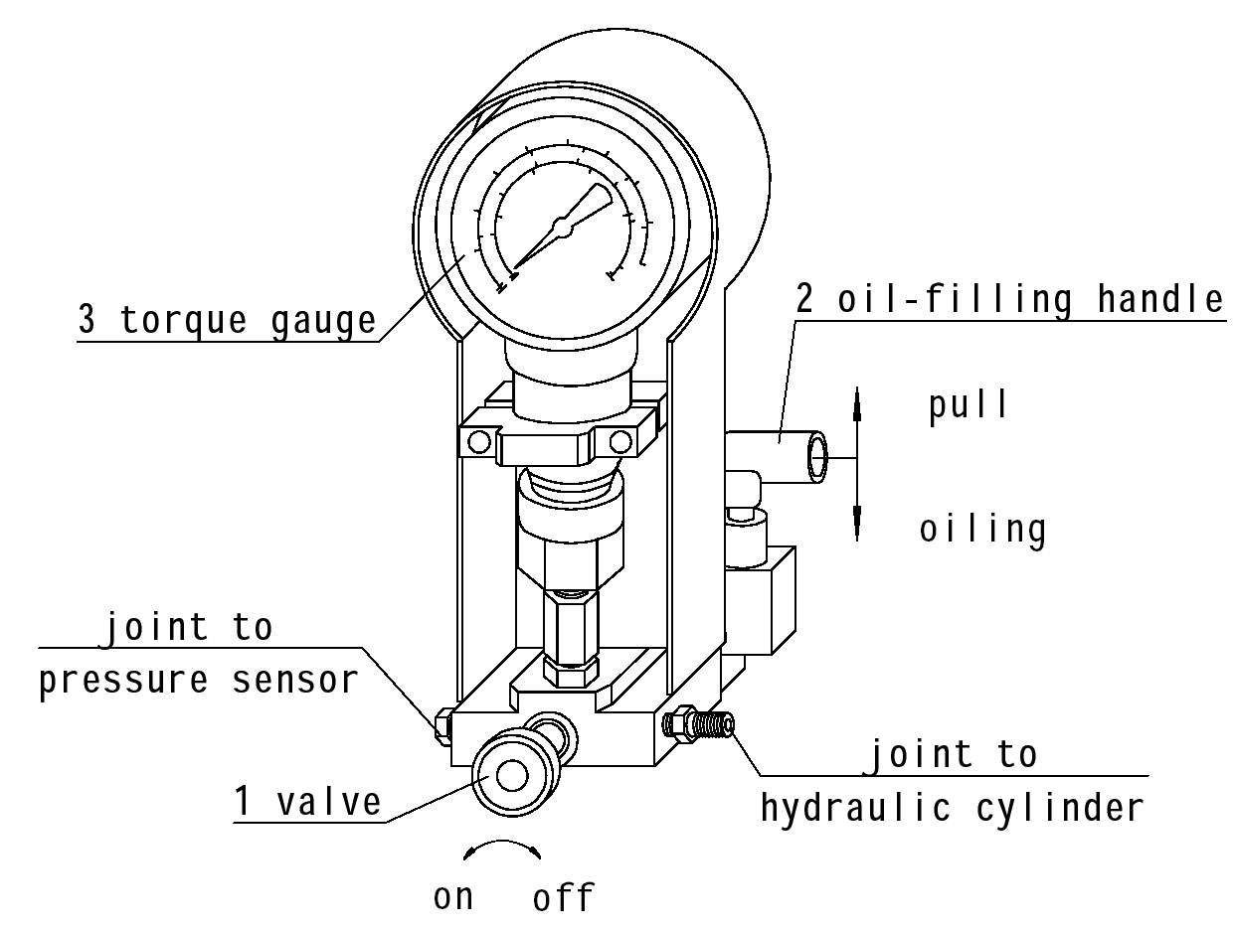

SECTION Ⅹ RECOMMENDED SPARE PARTS
No. | Part No. | Description | Unit Number | For Which Site | Remarks
1 | 24.100-03 | Die | 20 | Jaw
2 | 24.100-02 | Jaw shaft | 2 | Tong head
3 | 56.600-04 | Cam | 4 | Tong head
4 | 52.100-15C | Clutch gear | 1 | Gearshift device
5 | 52.100-17C | Dial fork | 1 | Gearshift device
6 | 56.520.00 | Brake band | 1 | Tong head
7 | 56.540.00 | Big roller parts | 22 | Tong head
8 | 56.610.00 | Jaw assy. 51/2” | 2 | Tong head
9 | 56.620.00 | Jaw assy.7” | 2 | Tong head
10 | 56.630.00 | Jaw assy. 95/8” | 2 | Tong head
11 | 56.640.00 | Jaw assy. 133/8” | 2 | Tong head
12 | 56.650.00 | Small roller parts | 38 | Tong head
13 | 20.13.10.00 | Torque cylinder | 1
14 | DL-F20L-T/Y-T/O | Multi-way reverse valve | 1

Bearing
Item | Part No. | Description | Unit Number | For Which Site | Remarks
1 | GB/T5801 | Bearing RNA4904 | 4 | Guard door | Φ25×Φ37×17
2 |  | Bearing K50×58×20 | 2 | Gearshift device | Φ50×Φ58×20
3 |  | Bearing K45×53×20 | 4 | Gearshift device | Φ45×Φ53×20
4 |  | Bearing 644907 | 22 | Big roller parts | Φ38×Φ58×32
5 | GB5801-86 | Bearing 4084106 | 3 | Dual gear | Φ40.1×Φ55×25
6 | GB5801-86 | Bearing 4624906 | 10 | Centralizing roller | Φ35×Φ47×17

Sealing element
Item | Part No. | Description | Unit Number | For Which Site | Remarks
1 | JB982-77 | Washer 33 | 1 | Hydraulic line
2 | JB982-77 | Washer 30 | 4 | Hydraulic line
3 | JB982-77 | Washer 27 | 2 | Hydraulic line
4 | JB982-77 | Washer 18 | 2 | Hydraulic line
5 | JB/ZQ4224-97 | O ring 35×3.1 | 1 | Hydraulic line
6 | JB/ZQ4224-97 | O ring 30×3.1 | 5 | Hydraulic line
7 | JB/ZQ4224-97 | O ring 16×2.4 | 4 | Hydraulic line
8 | JB/ZQ4224-97 | O ring 46×3.5 | 1 | Torque cylinder
9 | GB1235-76 | Retainer ring | 1 | Torque cylinder
10 | GSD0650 | Step ring D65 | 1 | Torque cylinder
11 | GST | Guide ring D65×6.3 | 1 | Oil filler
12 | GB3452.1 | O ring 26502120 | 1 | Oil filler
13 | GB3452.1 | O ring 26501180 | 3 | Oil filler
14 | JB/ZQ4224-97 | O ring 22×2.4 | 3 | Oil filler
15 | 24.420-07 | Seal gasket | 1 | Oil filler
16 | 24.420-15 | Copper gasket | 1 | Oil filler
SECTION Ⅺ HYDRAULIC LIFT CYLINDER
1. The casing power tong is equipped with Hydraulic Lift Cylinder to permit the upward or downward height adjusting of the tong.
2. Installation for the cylinder: shackle(3) of lift cylinder is to joint with spring hanger assy. Pressure hose (2) is to connect with the joint in the throttle valve (4) of multi-way manual reversing valve. (See the following drawing).
3. Control the handle of multi-way reverse valve to perform the lifting and lowering of power tong. Hydraulic check valve (5) is to control the power tong at a certain position
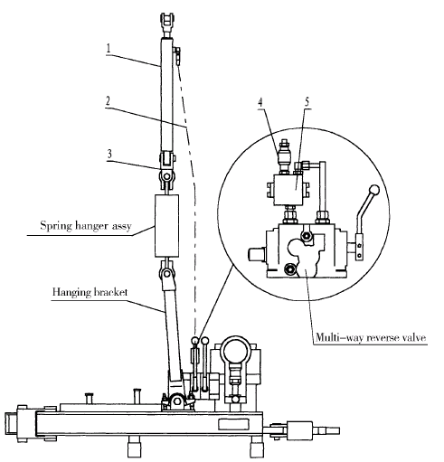

No. | Part No. | Description | Qty.
1 | HSGL01-50/32E*615 | Hydraulic cylinder | 1
2 | JB/ZQ4427-86 | Hose with A type joint  6.3II*2500 | 1
3 | M4BW3.2 | Shackle | 1
4 | MK8G1.2/2 | One-way throttle valve | 1
5 | SV10GA2-30/2 | Hydraulic check valve | 1

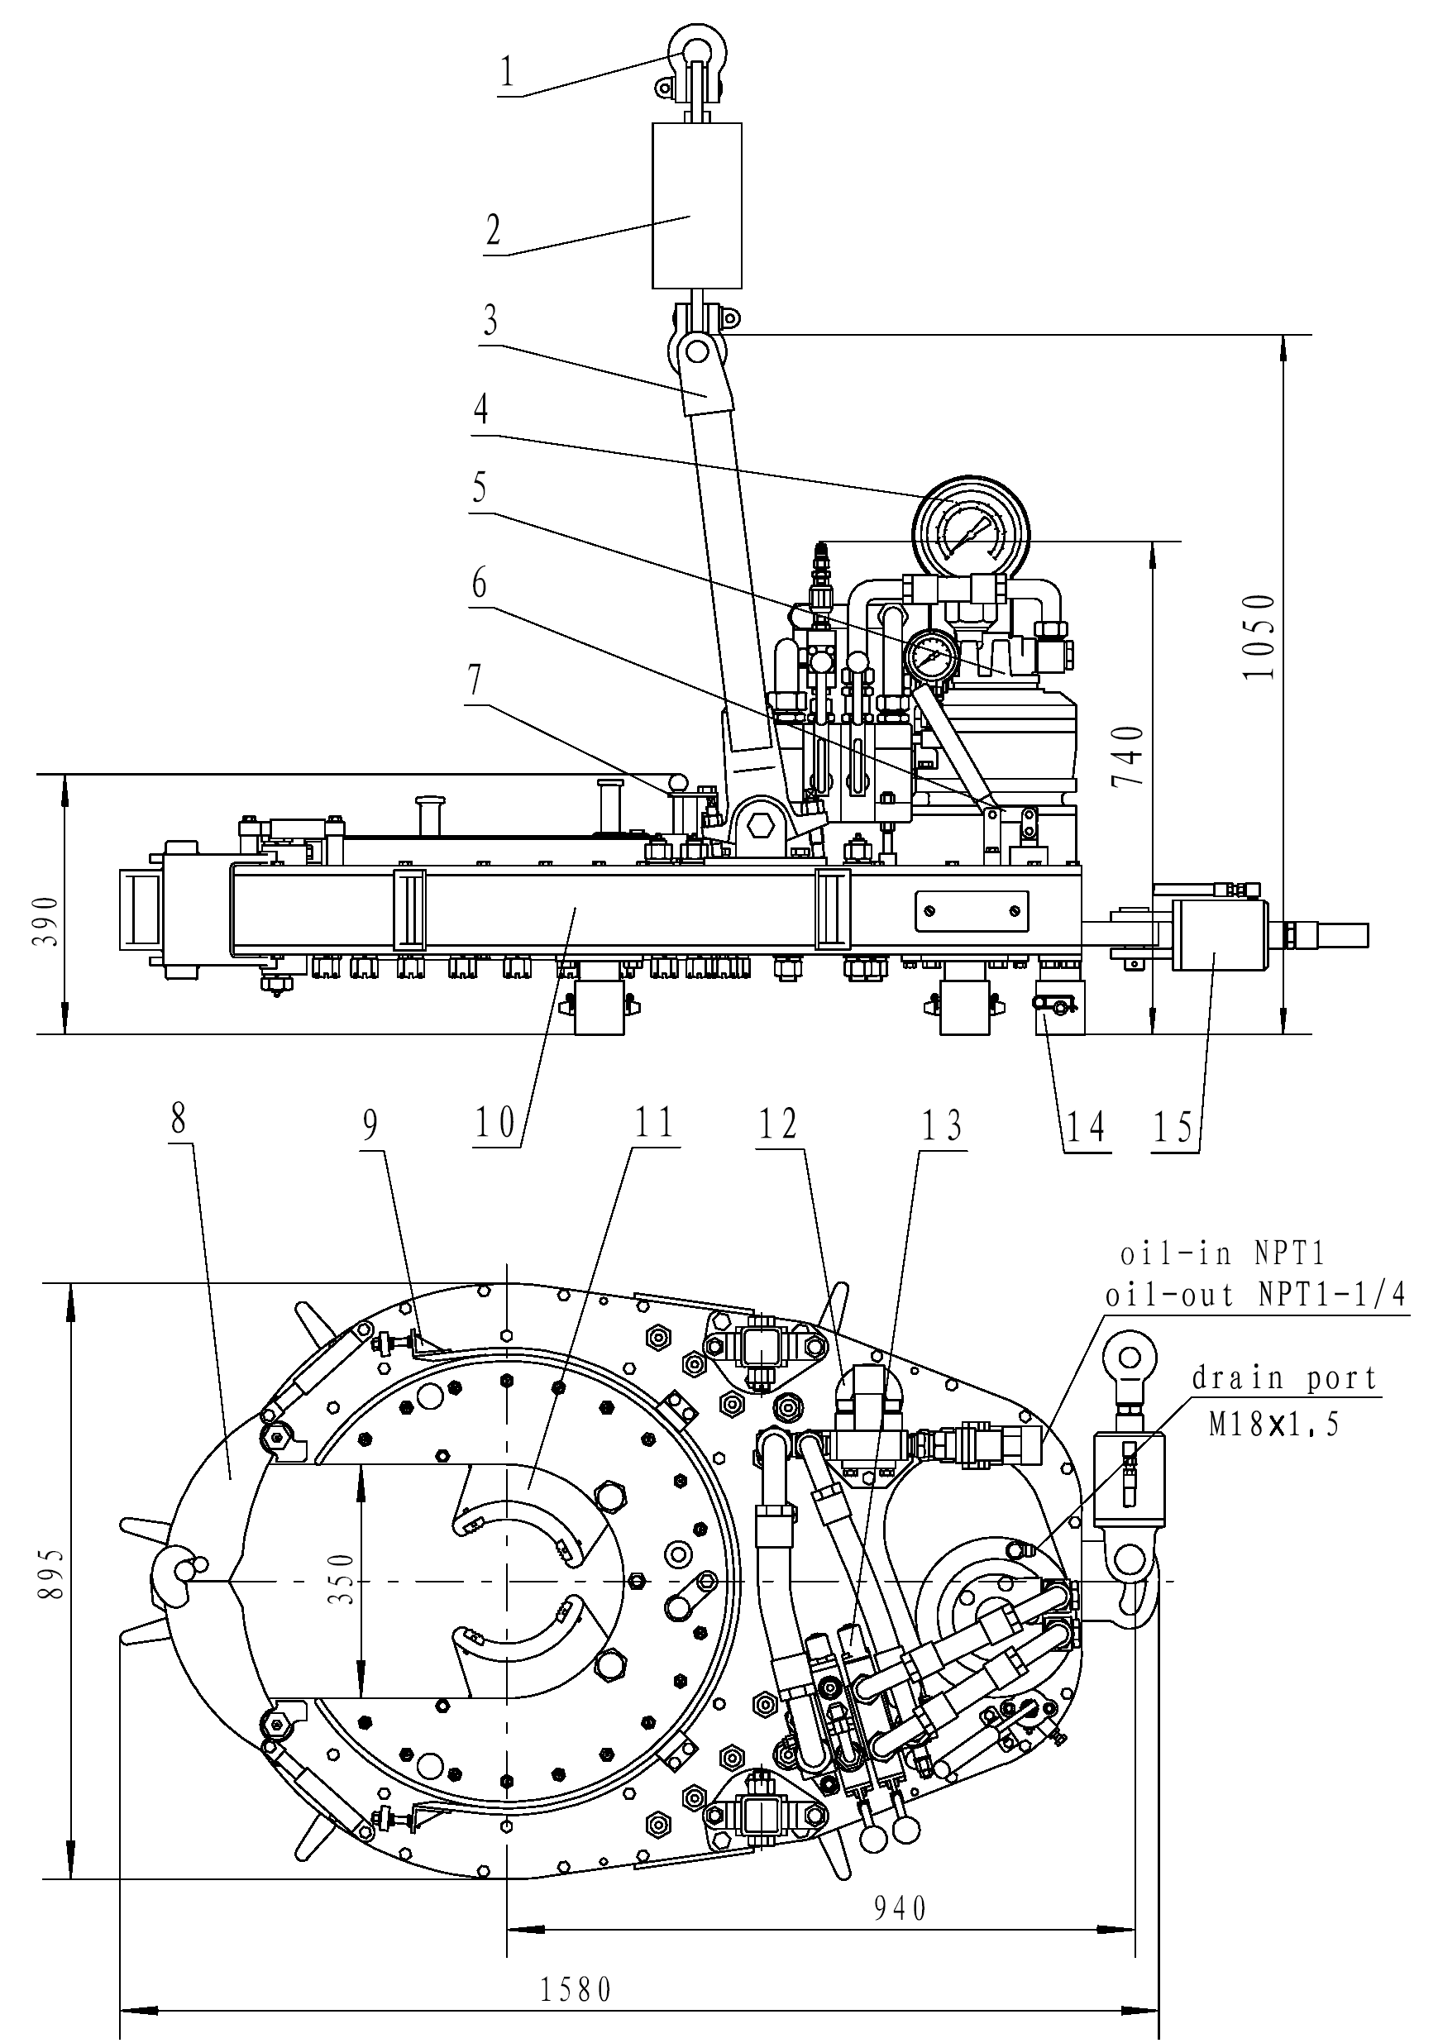

1.shackle 2.spring hanger assy. 3.hanging bracket 4.torque gauge 5. Hydraulic motor 6.gear-shifting device 7.backing pin 8.safety door 9.brake band 10.transmissin gear case 11.jaw assy. 12.speed-measuring gear 13.hydraulic system 14.support foot 15.torque cylinder
Fig.1 Outside Drawing of TQ340-35Y₂ casing tong
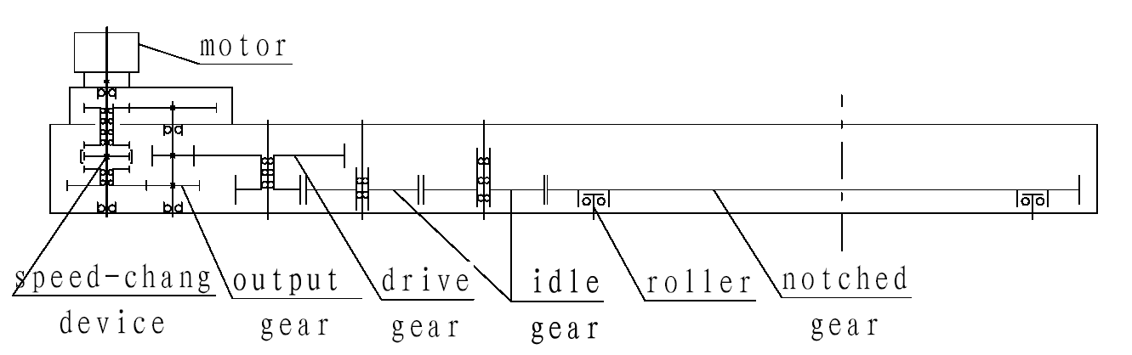
Fig.2 Transmission Diagram of TQ340-35Y casing tong

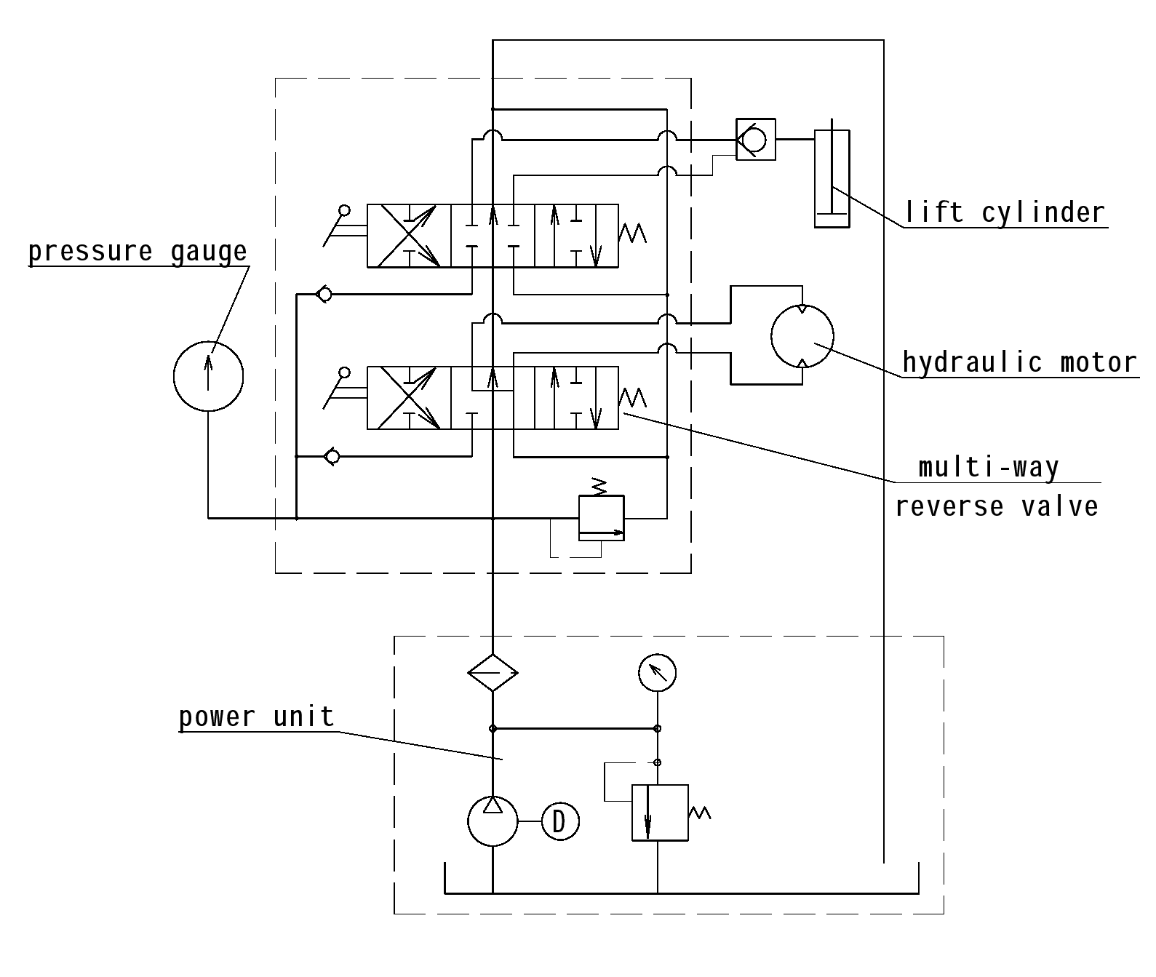

Fig.3 Principle Scheme of Hydraulic System for TQ340-35Y casing tong

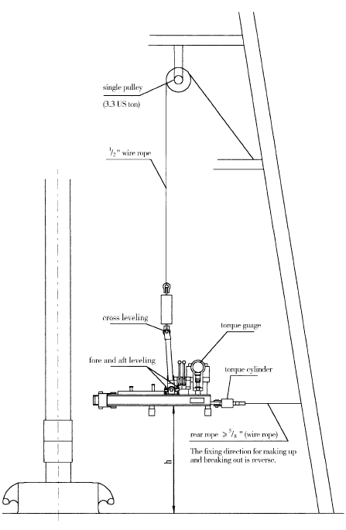

Fig.4 Suspension View of the Casing Tong

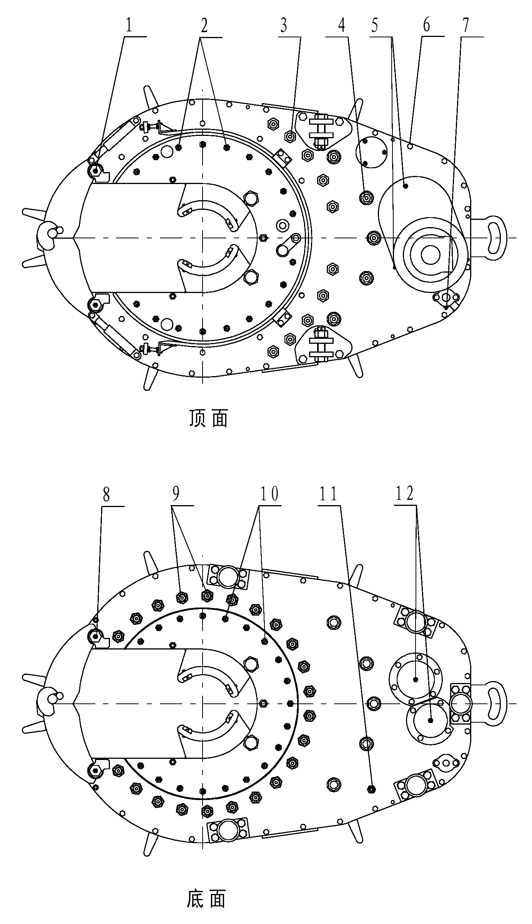

TOP

Bottom

Fig.5 Lubrication Schematic Diagram For Casing Tong

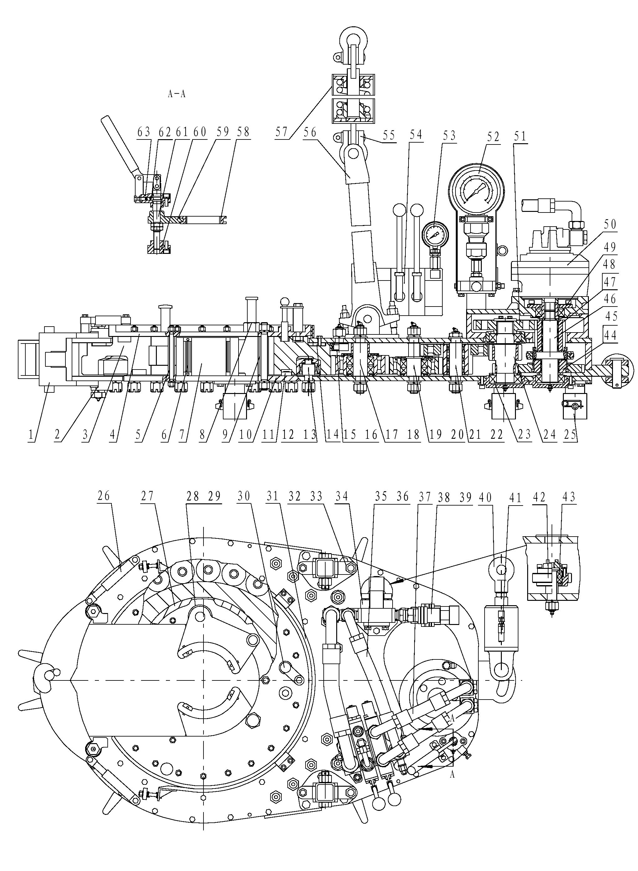

Fig.6 The General Layout of TQ340-35Y₂ casing tong
TOP
No. | Part No. | Name | Qty | Note
1 | 56.510.00B | Safety door | 1
2 | GB5801-94 | Bearing RNA4904 | 4
3 | 56.600-03A | Notched gear | 1
4 | 56.660.00 | Upper jaw rack | 1
5 | 56.605.00 | Front locating shaft | 2
6 | 24.100-03 | Die | 4
7 | 56.610.00 | Jaw assembly 5¹/₂″ | 2
7 | 56.620.00 | Jaw assembly 7″ | 2
7 | 56.630.00 | Jaw assembly 9⁵/₈″ | 2
7 | 56.640.00 | Jaw assembly 13³/₈″ | 2
7 |  | Jaw assembly 4″、4¹/₂″、5″、7⁵/₈″、10³/₄″、12³/₄″ | 2/each | Special order
8 | 24.100-02 | Jaw shaft | 2
9 | 24.230.00 | Back locating shaft | 1
10 | 56.600-01 | Lower jaw rack | 1
11 | 56.650.00 | Small roller parts | 38
12 | 56.540.00 | Large roller set | 22
13 |  | Bearing 644907 | 22 | Ø38* Ø58*32
14 | 52.210-03 | Anti-wear bedplate | 1
15 | 26.230.00 | Centralizing roller | 10
16 | GB5801-86 | Bearing 4624906 | 10 | Ø35* Ø47*17
17 | 56.550.00A | Idler II | 2
18 | GB5801-86 | Bearing 22209C/W33 | 6 | Ø45* Ø85*23
19 | 52.230.00 | Idler I | 2
20 | GB/T283-94 | Bearing N209E | 2 | Ø45* Ø85*19
21 | 52.220.00 | Dual gear group | 1
22 | GB5801-86 | Bearing 4084106 | 3 | Ø40.1* Ø55*25
23 | GB/T288-1994 | Bearing 22211C/W33 | 2 | Ø55* Ø100*25
24 | 52.100-09C | Dual gear shaft | 1
25 | 24.130.00A | Support foot | 5
26 | 24.120.00 | Restoration rod | 2
27 | 56.600-04 | cam | 4
28 | 56.610-03 | Roller Ø100 | 2
28 | 56.620-02 | Roller Ø75 | 4
28 | 56.640-03 | Roller Ø50 | 2

No. | Part No. | Name | Qty | Note
29 | 56.610-02 | Roller shaft | 8
30 | 24.210.00 | Reverse pin | 1
31 | 56.520.00 | Brake band | 1
32 | 01.05-16M | Adjusting screw 20 | 2
33 | 14.05-05 | Adjusting screw M16 | 2
34 | DB20-1-50/31.5 | Relief valve | 1
35 | JB1885 | Pressure hose 22Ⅲ*430 | 1 | M36*2
36 | JB1885 | Pressure hose 32Ⅰ*460 | 1 | M42*2
37 | JB1885 | Pressure hose 22Ⅲ*650 | 2 | M36*2
38 |  | NPT1″self-sealing joint | 1
39 |  | NPT1¹/₄″self-sealing joint | 1
40 | 20.13.10.00 | Torque cylinder | 1
41 | JB/ZQ4427-86 | Hose joint 6.3Ⅱ-1000 | 1 | M14*1.5
42 | 24.140.00 | Speed-measuring system | 1
43 | GB/T276-94 | Bearing 6004 | 2 | Ø20*Ø42*12
44 | 52.110.00C | Speed increase gear set | 1
45 |  | Bearing K50*58*20 | 2
46 | 52.100-12C | Output shaft | 1
47 | 52.120.00C | Speed decrease gear set | 1
48 |  | Bearing K45*53*20 | 4
49 | GB/T288-94 | Bearing 22210/W33 | 2 | Ø50*Ø90*23
50 | BJM1-300HP1 | Hydraulic motor | 1
51 | 52.100-05C | Splined gear | 1
52 | YN150 | Pressure-torque gauge | 1 | 25MPa,45kN.m
53 | YN60 | Pressure gauge (0-25MPa) | 1
54 | DL-F20L-T/Y-T/O | Multi-reversing valve | 1
55 | JB/T8112-99 | Shackle M-BW3.2 | 2
56 | 52.300.00A | Hanging bracket | 1
57 | 56.100.00 | Suspension spring assy. | 1
58 | 52.100-15C | Clutch gear sleeve | 2
59 | 52.100-17C | Dial fork | 1
60 | 52.100-18C | Lower guide seat | 1
61 | 52.100-19C | Fork shaft | 1
62 | GB/T308-94 | Steel ball 8.5 | 1
63 | 52.100-21C | Upper guide seat | 1
SECTION Ⅻ API RECOMMENDED TORQUE FOR 4¹/₂″-13³/₈″CASING PIPE
OD | Weight  (Kg/m) | Grade of steel | Torque (N.m)
OD | Weight  (Kg/m) | Grade of steel | Short thread |  |  | Long thread
OD | Weight  (Kg/m) | Grade of steel | Best | Min. | Max. | Best | Min. | Max.
4¹/₂″ | 14.14 | H-40 | 1063 | 800 | 1325 | -- | -- | --
4¹/₂″ | 14.14 | J-55 | 1394 | 1049 | 1739 | -- | -- | --
4¹/₂″ | 15.62 | J-55 | 1822 | 1366 | 2277 | -- | -- | --
4¹/₂″ | 17.26 | J-55 | 2125 | 1601 | 2663 | 1835 | 1380 | 2290
4¹/₂″ | 14.14 | K-55 | 1546 | 1159 | 1932 | -- | -- | --
4¹/₂″ | 15.62 | K-55 | 2015 | 1518 | 2525 | -- | -- | --
4¹/₂″ | 17.26 | K-55 | 2346 | 1766 | 2939 | 2484 | 1863 | 3105
4¹/₂″ | 17.26 | C-75 | -- | -- | -- | 2967 | 2222 | 3712
4¹/₂″ | 20.09 | C-75 | -- | -- | -- | 3588 | 2691 | 4485
4¹/₂″ | 17.26 | N-80 | -- | -- | -- | 3146 | 2360 | 3933
4¹/₂″ | 20.09 | N-80 | -- | -- | -- | 3809 | 2857 | 4761
4¹/₂″ | 17.26 | C-95 | -- | -- | -- | 3560 | 2677 | 4457
4¹/₂″ | 20.09 | C-95 | -- | -- | -- | 4319 | 3243 | 5396
4¹/₂″ | 17.26 | P-110 | -- | -- | -- | 4168 | 3133 | 5216
4¹/₂″ | 20.09 | P-110 | -- | -- | -- | 5051 | 3795 | 6320
4¹/₂″ | 22.47 | P-110 | -- | -- | -- | 6072 | 4554 | 7590
5″ | 17.11 | J-55 | 1835 | 1380 | 2291 | -- | -- | --
5″ | 19.34 | J-55 | 2332 | 1753 | 2912 | 2512 | 1891 | 3146
5″ | 22.32 | J-55 | 2857 | 2139 | 3574 | 3077 | 2305 | 3850
5″ | 17.11 | K-55 | 2029 | 1518 | 2539 | -- | -- | --
5″ | 19.34 | K-55 | 2567 | 1932 | 3215 | 2774 | 2084 | 3464
5″ | 22.32 | K-55 | 3146 | 2360 | 3933 | 3395 | 2553 | 4250
5″ | 22.32 | C-75 | -- | -- | -- | 4085 | 3064 | 5106
5″ | 26.78 | C-75 | -- | -- | -- | 5203 | 3905 | 6500
5″ | 22.32 | N-80 | -- | -- | -- | 4333 | 3257 | 5423
5″ | 26.78 | N-80 | -- | -- | -- | 5520 | 4140 | 6900
5″ | 22.32 | C-95 | -- | -- | -- | 4913 | 3685 | 6141
5″ | 26.78 | C-95 | -- | -- | -- | 6279 | 4706 | 7852
5″ | 22.32 | P-110 | -- | -- | -- | 5755 | 4319 | 7190
5″ | 26.78 | P-110 | -- | -- | -- | 7079 | 5492 | 9163
5¹/₂″ | 20.83 | H-40 | 1794 | 1352 | 2249 | -- | -- | --
5¹/₂″ | 20.83 | J-55 | 2374 | 1780 | 2967 | -- | -- | --
5¹/₂″ | 23.06 | J-55 | 2788 | 2098 | 3491 | 2995 | 2249 | 3740
5¹/₂″ | 25.30 | J-55 | 3160 | 2374 | 3947 | 3409 | 2553 | 4264
5¹/₂″ | 20.83 | K-55 | 2608 | 1960 | 3257 | -- | -- | --
5¹/₂″ | 23.06 | K-55 | 3064 | 2305 | 3836 | 3298 | 2247 | 4126
5¹/₂″ | 25.30 | K-55 | 3478 | 2608 | 4347 | 3798 | 2815 | 4692
5¹/₂″ | 25.30 | C-55 | -- | -- | -- | 4513 | 3381 | 5644
5¹/₂″ | 29.76 | C-75 | -- | -- | -- | 5561 | 4168 | 6955
OD | Weight  (Kg/m) | Grade of steel | Torque (N.m)
OD | Weight  (Kg/m) | Grade of steel | Short thread |  |  | Long thread
OD | Weight  (Kg/m) | Grade of steel | Best | Min. | Max. | Best | Min. | Max.
5¹/₂″ | 34.22 | C-75 | -- | -- | -- | 6527 | 4899 | 8156
5¹/₂″ | 25.30 | N-80 | -- | -- | -- | 4802 | 3602 | 6003
5¹/₂″ | 29.76 | N-80 | -- | -- | -- | 5906 | 4430 | 7383
5¹/₂″ | 34.22 | N-80 | -- | -- | -- | 6928 | 5203 | 8666
5¹/₂″ | 25.30 | C-95 | -- | -- | -- | 5465 | 4099 | 6831
5¹/₂″ | 29.76 | C-95 | -- | -- | -- | 6721 | 5037 | 8404
5¹/₂″ | 34.22 | C-95 | -- | -- | -- | 7894 | 5920 | 9867
5¹/₂″ | 25.30 | P-110 | -- | -- | -- | 6376 | 4789 | 7976
5¹/₂″ | 29.76 | P-110 | -- | -- | -- | 8225 | 5389 | 9778
5¹/₂″ | 34.22 | P-110 | -- | -- | -- | 9218 | 6914 | 11937
7″ | 25.30 | H-40 | 3671 | 2760 | 4595 | -- | -- | --
7″ | 38.69 | H-40 | 4692 | 3519 | 5865 | -- | -- | --
7″ | 29.76 | J-55 | 4002 | 3008 | 5009 | -- | -- | --
7″ | 34.22 | J-55 | 5134 | 3850 | 6417 | 4319 | 3243 | 5396
7″ | 38.69 | J-55 | 6251 | 4692 | 7811 | 5065 | 3795 | 6334
7″ | 29.76 | K-55 | 7618 | 5713 | 9522 | -- | -- | --
7″ | 34.22 | K-55 | 8804 | 6610 | 11012 | 4706 | 3533 | 5879
7″ | 38.69 | K-55 | 6638 | 4982 | 8294 | 5603 | 4154 | 6914
7″ | 34.22 | C-75 | -- | -- | -- | 5741 | 4306 | 7176
7″ | 38.69 | C-75 | -- | -- | -- | 6748 | 5065 | 8432
7″ | 43.15 | C-75 | -- | -- | -- | 7756 | 5824 | 9701
7″ | 47.62 | C-75 | -- | -- | -- | 8735 | 6555 | 10916
7″ | 52.08 | C-75 | -- | -- | -- | 9701 | 7273 | 12130
7″ | 56.54 | C-75 | -- | -- | -- | 10585 | 7935 | 13234
7″ | 34.22 | N-80 | -- | -- | -- | 6100 | 4582 | 7631
7″ | 38.69 | N-80 | -- | -- | -- | 7162 | 5368 | 8956
7″ | 43.15 | N-80 | -- | -- | -- | 8239 | 6182 | 10295
7″ | 47.62 | N-80 | -- | -- | -- | 9274 | 6955 | 11592
7″ | 52.08 | N-80 | -- | -- | -- | 10295 | 7728 | 12875
7″ | 56.54 | N-80 | -- | -- | -- | 11233 | 8432 | 14048
7″ | 34.22 | C-95 | -- | -- | -- | 6969 | 5230 | 8708
7″ | 38.69 | C-95 | -- | -- | -- | 8183 | 6141 | 10226
7″ | 43.15 | C-95 | -- | -- | -- | 9425 | 7066 | 11785
7″ | 47.62 | C-95 | -- | -- | -- | 10598 | 7949 | 13248
7″ | 52.08 | C-95 | -- | -- | -- | 11771 | 8832 | 14711
7″ | 56.54 | C-95 | -- | -- | -- | 12848 | 9632 | 6063
7″ | 38.69 | P-110 | -- | -- | -- | 9563 | 7176 | 11868
7″ | 43.15 | P-110 | -- | -- | -- | 10999 | 8252 | 13745
7″ | 47.62 | P-110 | -- | -- | -- | 12130 | 9287 | 15470
7″ | 52.08 | P-110 | -- | -- | -- | 13745 | 10309 | 17181
7″ | 56.54 | P-110 | -- | -- | -- | 15001 | 11247 | 18754
OD | Weight  (Kg/m) | Grade of steel | Torque (N.m)
OD | Weight  (Kg/m) | Grade of steel | Short thread |  |  | Long thread
OD | Weight  (Kg/m) | Grade of steel | Best | Min. | Max. | Best | Min. | Max.
9⁵/₈″ | 48.05 | H-40 | 3500 | 2650 | 4400 | -- | -- | --
9⁵/₈″ | 53.56 | H-40 | 4100 | 3100 | 5100 | -- | -- | --
9⁵/₈″ | 53.56 | J-55 | 5400 | 4100 | 6800 | 63000 | 4700 | 7800
9⁵/₈″ | 59.51 | J-55 | 6200 | 4700 | 7800 | 7200 | 5400 | 9000
9⁵/₈″ | 53.56 | K-55 | 5800 | 4400 | 7300 | 6800 | 5100 | 8500
9⁵/₈″ | 59.51 | K-55 | 6700 | 5000 | 8400 | 7800 | 5800 | 9700
9⁵/₈″ | 59.51 | C-75 | -- | -- | -- | 9600 | 7200 | 12000
9⁵/₈″ | 64.72 | C-75 | -- | -- | -- | 10700 | 8000 | 13400
9⁵/₈″ | 70.93 | C-95 | -- | -- | -- | 118000 | 8800 | 14700
9⁵/₈″ | 79.60 | C-75 | -- | -- | -- | 138000 | 10400 | 17300
9⁵/₈″ | 59.51 | N-80 | -- | -- | -- | 10200 | 7600 | 12700
9⁵/₈″ | 64.72 | N-80 | -- | -- | -- | 11400 | 8600 | 14200
9⁵/₈″ | 70.93 | N-80 | -- | -- | -- | 12500 | 9400 | 15600
9⁵/₈″ | 79.60 | N-80 | -- | -- | -- | 14700 | 11000 | 18400
9⁵/₈″ | 59.51 | C-95 | -- | -- | -- | 11700 | 8800 | 14600
9⁵/₈″ | 64.72 | C-95 | -- | -- | -- | 13100 | 9800 | 16400
9⁵/₈″ | 70.93 | C-95 | -- | -- | -- | 14400 | 10800 | 18000
9⁵/₈″ | 79.60 | C-95 | -- | -- | -- | 16900 | 12700 | 21100
9⁵/₈″ | 64.72 | P-110 | -- | -- | -- | 15300 | 11500 | 19100
9⁵/₈″ | 70.93 | P-110 | -- | -- | -- | 16800 | 12600 | 21000
9⁵/₈″ | 79.60 | P-110 | -- | -- | -- | 19700 | 14800 | 24600
13³/₈″ | 71.41 | H-40 | 4500 | 3300 | 5600 | -- | -- | --
13³/₈″ | 81.08 | J-55 | 7100 | 5300 | 8900 | -- | -- | --
13³/₈″ | 90.75 | J-55 | 8200 | 6200 | 10300 | -- | -- | --
13³/₈″ | 101.16 | J-55 | 9300 | 7000 | 11700 | -- | -- | --
13³/₈″ | 81.08 | K-55 | 7600 | 5700 | 9400 | -- | -- | --
13³/₈″ | 90.75 | K-55 | 8700 | 6600 | 10900 | -- | -- | --
13³/₈″ | 101.16 | K-55 | 9900 | 7500 | 12400 | -- | -- | --
13³/₈″ | 107.11 | C-75 | 13500 | 10200 | 16900 | -- | -- | --
13³/₈″ | 107.11 | N-80 | 14400 | 10800 | 18000 | -- | -- | --
13³/₈″ | 107.11 | C-95 | 16600 | 12500 | 20800 | -- | -- | --

